**Project Title:** File transfer using SSH

**Objectives:**

* This project is to understand & demonstrate the use of SCP (Secure Copy Protocol) that is use to securely copy files between Windows & Linux
* This project is to learn install necessary software on both Windows & Linux machine for using SCP
* This project is to provide knowledge about file transfer between Windows & Linux using SSH (SSH also known as Secure Shell, a network protocol that provide secure remote access, encrypted data communications and strong authentication)

**Methodology:**

Step 1: First, I am checking if ‘OpenSSH Server’ is installed in my Windows or not. So, for that I had to go to ‘Settings’ -> ‘System’ -> ‘Apps & features’ -> ‘Optional features’. In my Windows ‘OpenSSH Server’ is already installed.

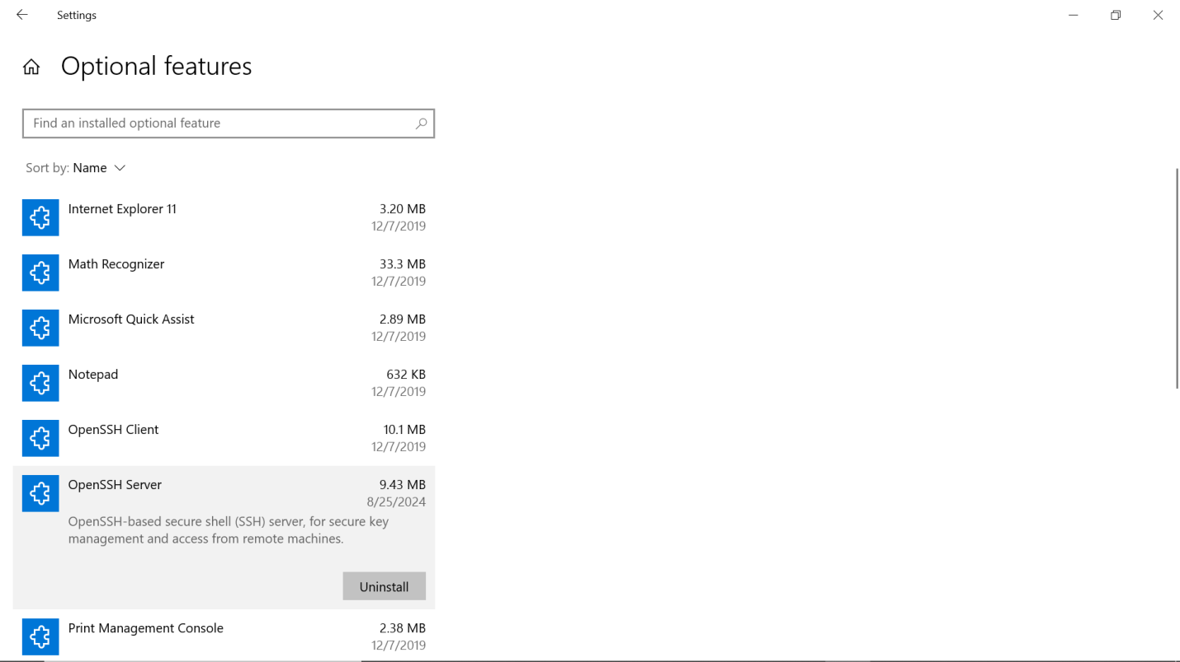

Step 2: Next I am activating the service of ‘OpenSSH Server’ in my Windows Operating system. For that I had to go to ‘Computer management’ -> ‘Services & Applications’ -> ‘Services’ -> ‘OpenSSH Server’ and I am setting the service into ‘Automatic’

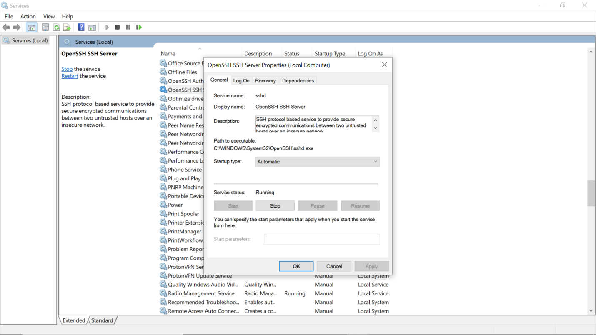

Step 3: Next I have logged in my Linux machine and I am installing ‘OpenSSH Server’ using command **sudo apt install openssh-server.**

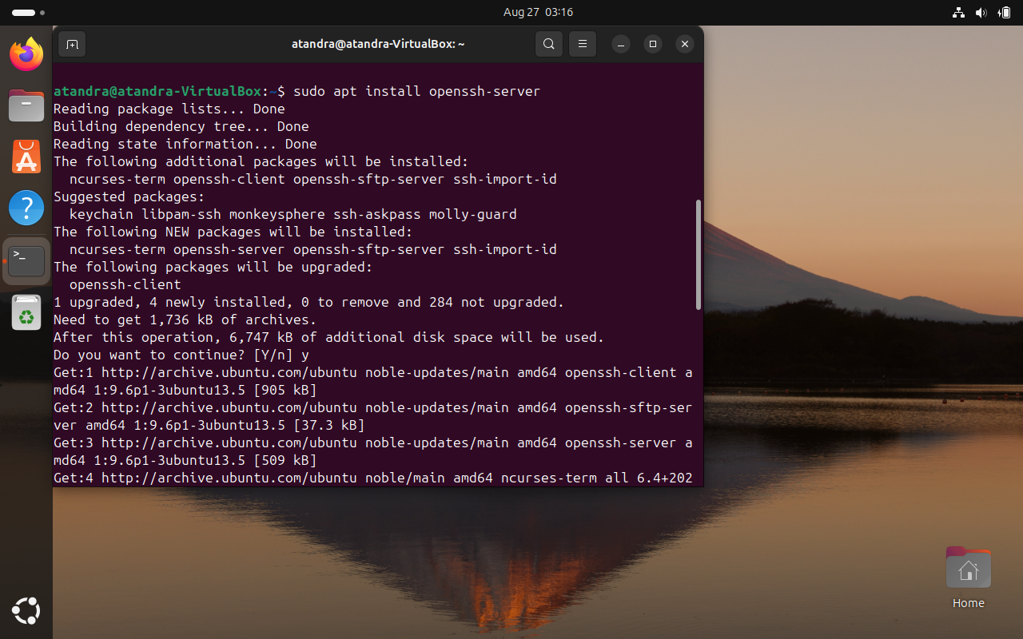

Step 4: After installing, I am checking if ‘OpenSSH Server’ is successfully installed or not by using command **sudo apt list --installed | grep openssh-server.** Here I am using ‘**apt list**’ command to list out all packages that are installed in my Linux machine and by ‘**grep’** command I am able to specify the name of the package that I am looking for.

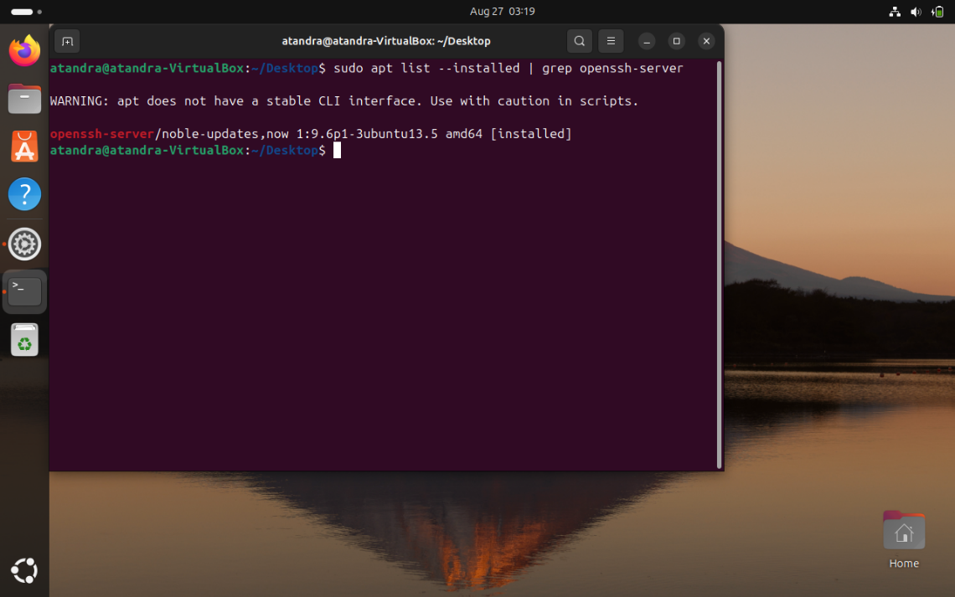

It's showing that ‘openssh-server’ is successfully installed.

Step 5: After installing ‘OpenSSH’ in my Linux machine, now I am checking if ‘SSH’ service is activate or not using command **sudo service ssh status.** Here I can see that my ‘SSH’ service is activated.

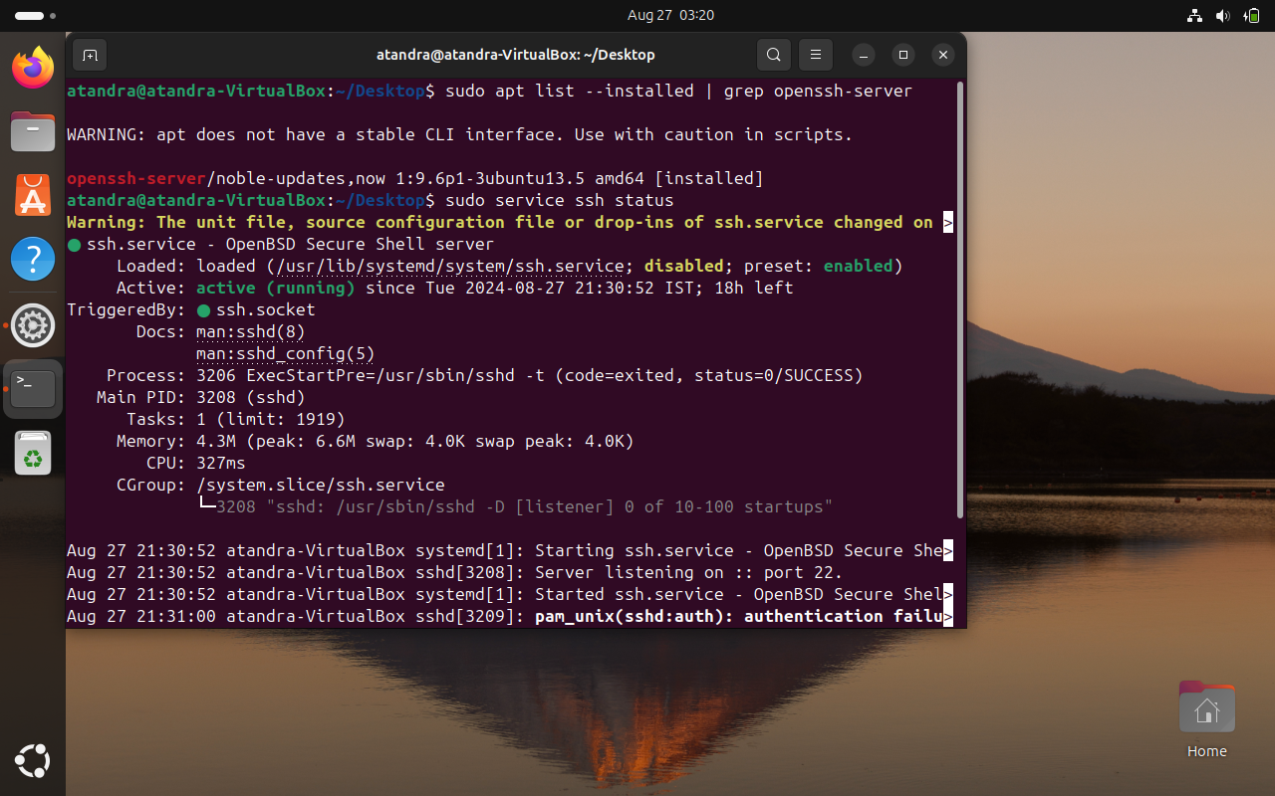

Step 6: I have a text file name ‘My File.txt’ which is located in my ‘Desktop’ directory in Linux. Now I want to send this ‘My File.txt’ file to my Windows machine using ‘**SCP’** command. So, for that I am using command **scp ‘My File.txt’** [**Test@192.168.0.106:C\Users\Test\Desktop**](mailto:Test@192.168.0.106:C\Users\Test\Desktop)**.** After entering this command, it will ask for the password of my Windows machine.

Here ‘Test’ is the username and ‘192.168.0.106’ is the IP address of my windows machine. ‘C:\Users\user\Desktop’ is the Path of my Windows machine, where this ‘My File.txt’ will be copied into.

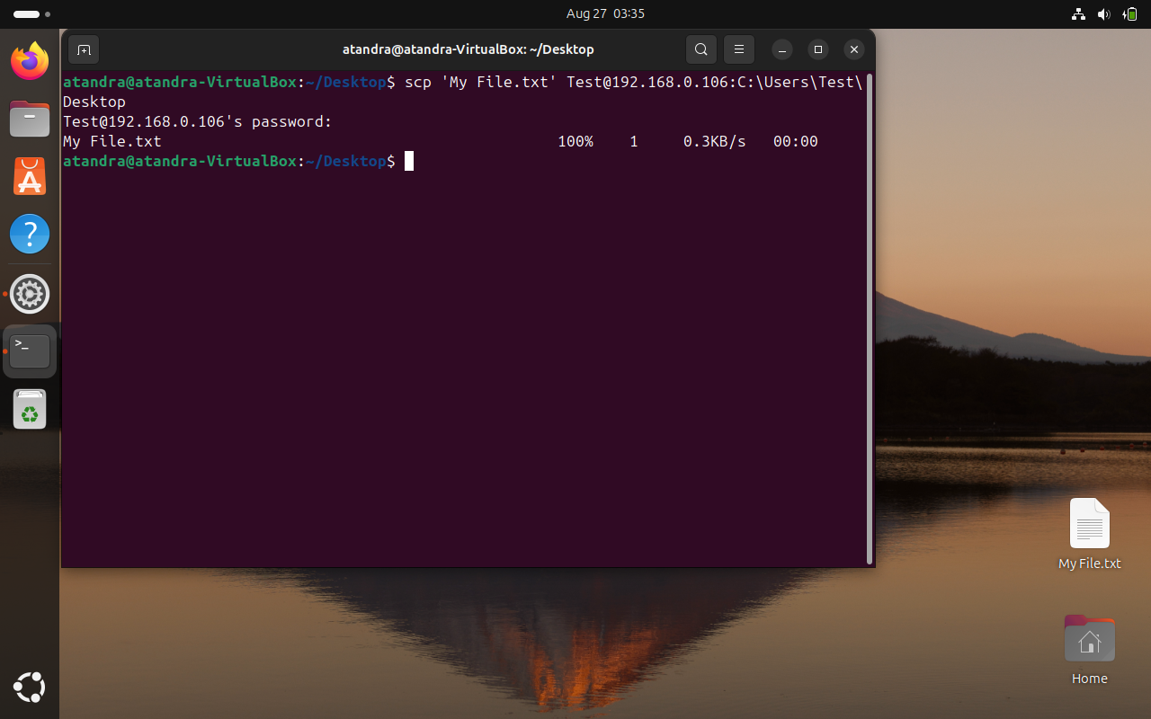

Now we can see the file has successfully transferred to my Windows machine.

Step 7: In my Windows machine I have text file called ‘New.txt’ which is located in the Desktop folder. Now I want to send this ‘New.txt’ file to my Linux machine using ‘**SCP’** command. So, for that I am using command **scp ‘New.txt’** [**atandra@192.168.0.105:/home/atandra/Desktop**](mailto:atandra@192.168.0.105:/home/atandra/Desktop)**.** After entering this command, it will ask for the password of my Linux machine.

Here ‘atandra’ is the username and ‘192.168.0.105’ is the IP address of my Linux machine. ‘/home/atandra/Desktop’ is the Path of my Linux machine, where this ‘New.txt’ will be copied into.

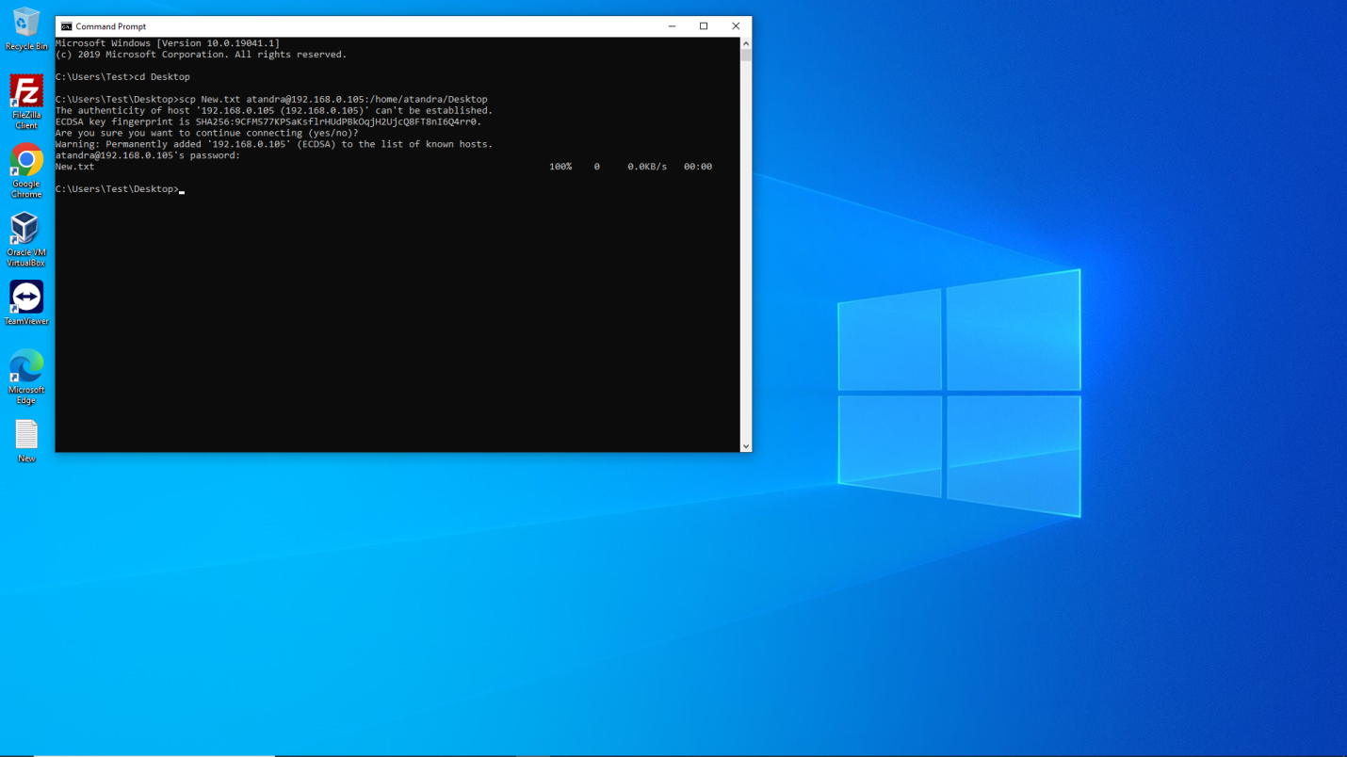

Now we can see the file has successfully transferred to my Windows machine.

**Conclusion:**

This project demonstrates the secure transfer of files between machines using SCP. The implementation of SSH based security ensures that all data is encrypted, making SCP a reliable method of transferring sensitive information across the network.

Through this project, we have successfully set up a secure file transfer mechanism, tested it across different platform and verified its reliability.